- Results and discussions
Water levels
The model calibration process considered adjustments in the original bathymetry of the Itaipu and Camboatá Channels, as well as in the river discharges. The available river discharges were originally obtained by HYDROSCIENCE (2018) as annual mean values, which do not necessarily represent precise river flow values for the simulation period. Tidal inlets’ bathymetry is also highly variable in response to daily changes in the environmental conditions – i.e. wave induced longshore sediment transport, fluvial discharge, tides. In this virtue, the performed adjustments in the bottom geometry of the Itaipu Channel provided a configuration more in accordance with the simulated period. The bottom of the Camboatá Channel, on the other hand, was not well described in the available bathymetry data, what led to the need of adjustments, in other to find a more real configuration.
Figure 6 compares the water level times series measured inside the Piratininga Lagoon with the model result after calibration for the RS. A very good agreement is observed between measured data and model results. Figure 7 shows the comparison between the model results and the measured data in the Itaipu Lagoon. Although the model results also agree with the measured data, some displacement between both time series may be observed during some moments. This occurs because, as previously discussed, the bathymetry of tidal inlets varies intensely in response to daily changes in environmental conditions. Since the applied hydrodynamical model considered a fixed bottom geometry, eventual morphological changes in the geometry of the Itaipu Channel were neglected. This assumption of fixed bottom geometry may have led to the observed displacement between the time series observed in Figure 7. However, it is notable that the model provided a satisfactory qualitative representation of the water level oscillations also in the Itaipu Lagoon.
The RS, used for model calibration and validation, considered environmental conditions observed during 22 September and 27 October 2018. In this scenario, the Tibau Tunnel was unobstructed, allowing direct connection between the Piratininga Lagoon and the ocean. On the other hand, both the Itaipu Channel and the Camboatá Channel exhibited significant levels of siltation, compromising their functionality in water exchange between the lagoons and with the sea.
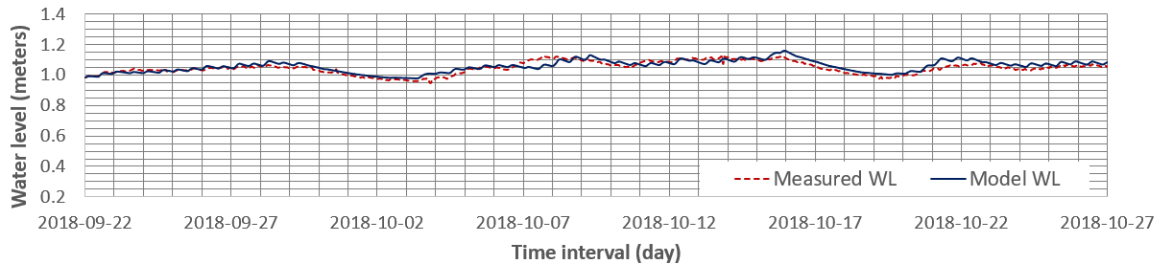
Figure 6 - Comparison between measured water level and model result, after calibration, for the Piratininga Lagoon. Reference Level: Nautical Chart 1511 Datum - DHN.
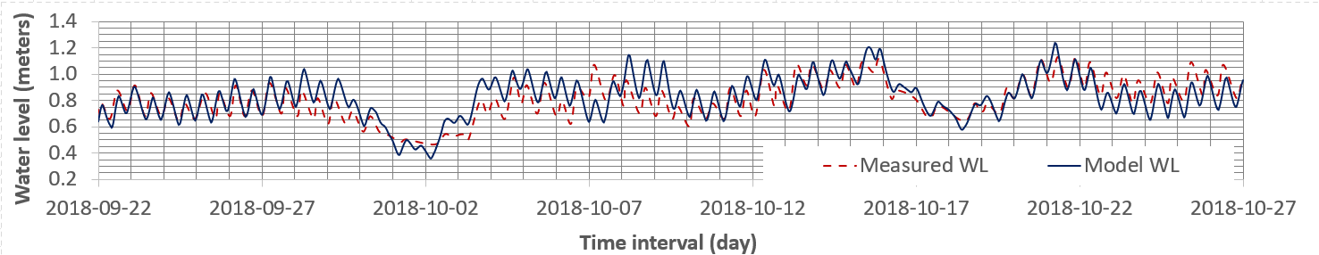
Figure 7 - Comparison between measured water level and model result for the Itaipu Lagoon, validating the calibration procedure. Reference Level: Nautical Chart 1511 Datum - DHN.
As Figure 8 depicts, the tidal amplitude within the Piratininga Lagoon is very diminished, even during more pronounced tidal periods, such as spring tides. This can be attributed to the limited cross section of the Camboatá Channel and to the sill at the mouth of the Tibau Tunnel – the sill crest level is 0.84 m. Although the sill prevents the lagoon level from dropping too low, exposing mudflats during low water tides, it also limits water renovation through the tidal flows. In contrast, the water level in the Itaipu Lagoon is directly influenced by tidal variations, a pattern which suggests a more effective water exchange with the sea.
The water levels in the Piratininga Lagoon were higher than those observed in the Itaipu Lagoon for approximately 97% of the simulated period. Likewise, when compared to the sea water level, the Piratininga Lagoon exhibited higher values for about 74% of the time. It should be noted that, throughout the entire simulation, the most significant water level oscillations in the Piratininga Lagoon occur in a time scale of days, in response to storm surge effects. Although also affected by storm surges, the water levels in the Itaipu Lagoon vary in an hourly time scale, in response to astronomical tide variation.
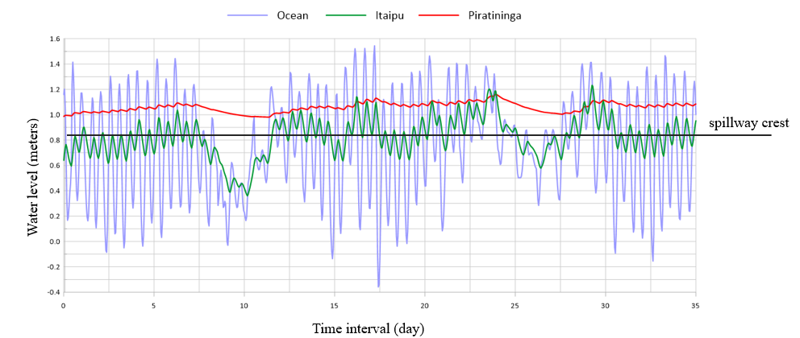
Figure 8 - Time series of water level variations in the RS of the lagoon system, for the points shown in Figure 3. Reference level: Chart Datum from Nautical Chart No. 1511 by the Brazilian Navy Hydrographic Directorate (DHN). The figure also highlights the crest of the sill, providing a clear indication of the hydraulic control point within the system.
Figure 9 compares water levels in the central portion of the Piratininga Lagoon for all the simulated scenarios. In the RS the water level ranges between 1.0 and 1.2 m. The observed higher frequency oscillations, which occur in a 12-hour timescale, are due to astronomical tides, while smaller frequency oscillations, which occur in a time scale of 3 to 8 days are caused by storm surges.
The TTO scenario, in which the Tibau Tunnel is obstructed, shows an increase around between 0.10 and 0.20 m in the water level, since in this situation the rivers discharges are drained only by the Camboatá Channel. The DIC scenario revealed no changes in the Piratininga Lagoon’s water level. Since the Camboatá Channel severely reduces water flow between both lagoons, the clearance of the Itaipu Channel affects mostly the Itaipu Lagoon hydrodynamics. On the other hand, when the Camboatá Channel is dredged – DCC scenario – the Piratininga Lagoon water level decreases 0.10 to 0.15 m, since the river discharges and tidal floodwaters drain easier to the Itaipu Lagoon, and afterwards to the sea. In comparison to the DCC scenario, in the HOC scenario the water level in the Piratininga Lagoon decreased no more than 0.05 m, which reveals that the dredging and clearence of the Camboatá Channel is the intervention which most affects the water level in that lagoon.

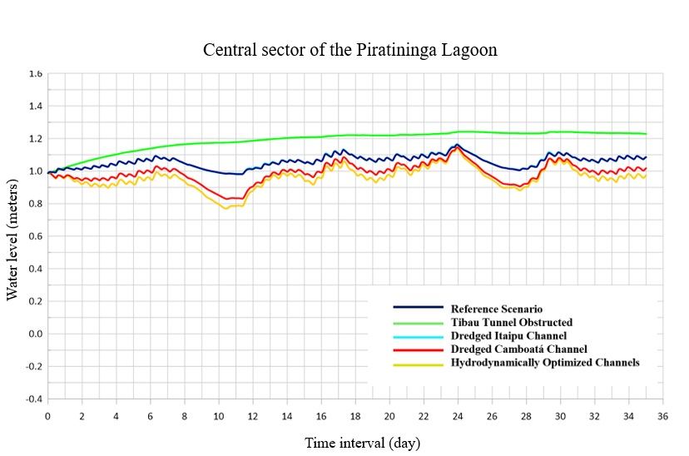
Figure 9 - Comparative analysis of simulations for the central sector of the Piratininga Lagoon.
For the Itaipu Lagoon (Figure 10), the DIC scenario significantly increased the tidal amplitude, indicating a more efficient connection with the sea when the Itaipu Channel is dredged. Higher tidal amplitudes were also observed in the scenario with optimized channels, although with a slight increase in the average water level, compared to the previous simulation. For the Itaipu Lagoon, the most affecting intervention was the dredging of the Itaipu Channel. In the other, only slightly changes were observed in the lagoon’s mean water level and tidal amplitude.

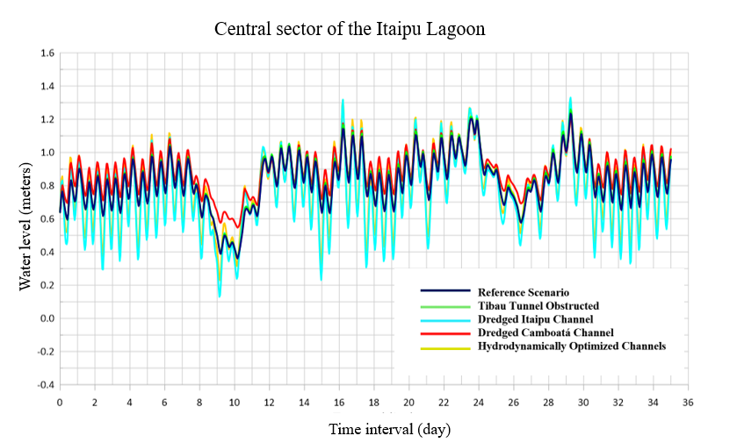
Figure 10 - Comparative analysis of simulations for the central sector of the Itaipu Lagoon.
Water renewal rate

The water age simulations considered a period of 70 days, composed of two cycles of the 35 days of available water level measured data. As Figure 11 presents the evolution of water renewal rates along the PILS, one may notice that the Piratininga and Itaipu Lagoons exhibit distinct and well-defined water renewal patterns. Since each lagoon has its own connection to the sea and their interconnection through the Camboatá Channel is limited, water renewal mechanisms operate differently in each lagoon. Throughout the simulated period, the water renewal in the Itaipu Lagoon occured gradually, driven both by marine water inflow and fluvial contributions. In contrast, in the Piratininga Lagoon, river inflows stand out as the main source of new water, highlighting a greater dependence on continental contributions for local hydrodynamics.

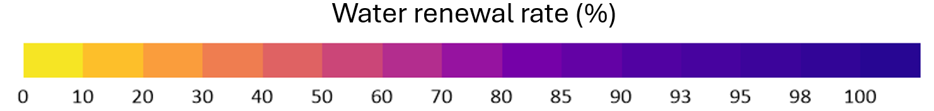
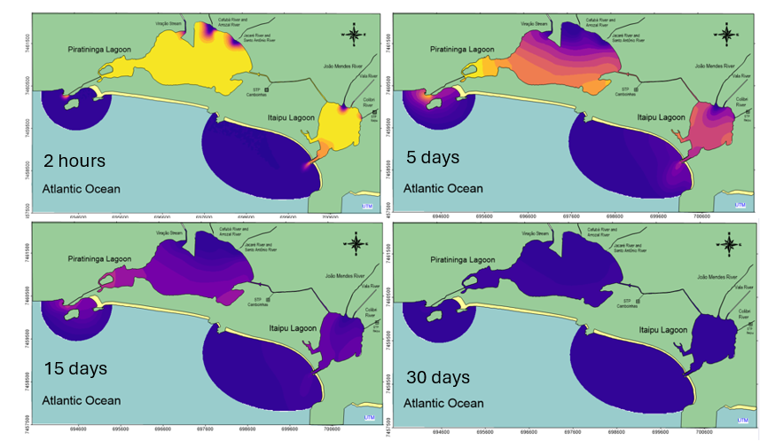
Figure 11 – Water renewal rates occurring gradually within the lagoon system after 2 hours, 5 days, 15 days and 30 days of the RS simulation.
Figure 12 presents the evolution of water renewal for the central sector of the Piratininga Lagoon. The HOC scenario was the most effective for water renewal, while the TTO was the least efficient. The obstruction of the Tibau Tunnel retarded water renewal in about 5% during most of the simulation. Once the central portion of the Piratininga Lagoon was mainly influenced by river discharges, the obstruction of the Tibau Tunnel did not affect severely the water renewal rates in that region. In virtue of this, the results obtained were not so discrepant among the simulated scenarios.
In contrast to the observed in central sector of the Piratininga Lagoon, the Tibau Tunnel plays a critical role in water renewal at the western portion. As Figure 13 reveals, when the Tunnel is obstructed, the water renewal rate can be up to 55% lower than in the RS. Dredging the Camboatá Channel accelerated the speed of water renewal in the first 15 days, with subsequent stabilization after that. The geometry of the Itaipu Channel seems not to significantly interfere in water renewal rates in the western portion of the Piratininga Lagoon, since the line of the DIC and RS scenarios are superposed in Figure 13. The speed of water renewal, as well the water renewal rates are quite high in the OC, revealing that the Tibau Tunnel and the Camboatá Channel are both important for that portion of the Piratininga Lagoon.

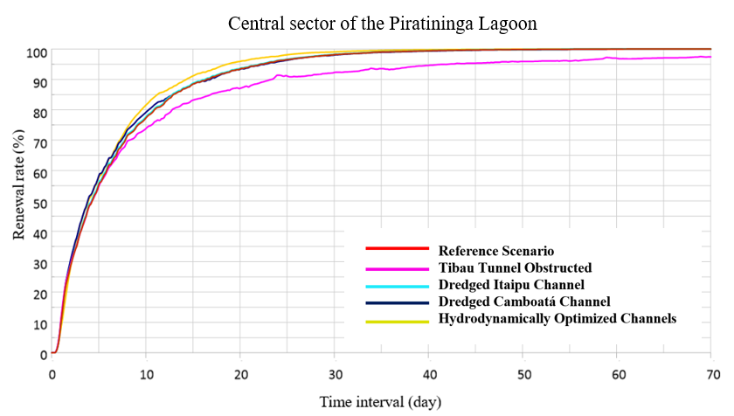
Figure 12 - Comparative renewal time series among the simulations analyzed for the central sector of Piratininga Lagoon.

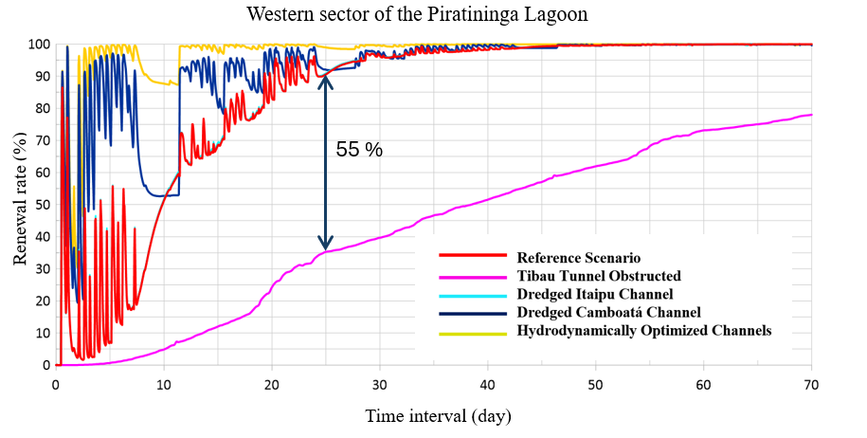
Figure 13 - Comparative renewal time series among the simulations analyzed for the western sector of Piratininga Lagoon.
For the central region of the Itaipu Lagoon (Figure 14), the DIC scenario was most efficient in increasing water renewal, providing higher water renewal rates from the early stages of the simulation. As already observed in Figure 10, the other scenarios do not alter significantly the hydrodynamical behavior of the Itaipu Lagoon.

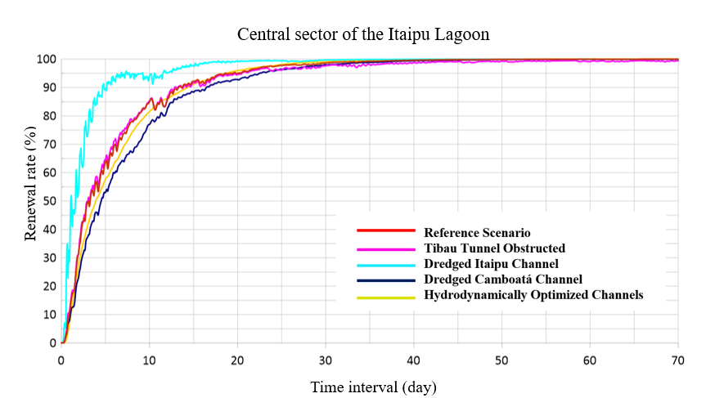
Figure 14 - Comparative renewal time series among the simulations analyzed for the central sector of Itaipu Lagoon.

Water Age

The objective of the water age simulations was to identify regions of the PILS with greater tendency toward water stagnation. As Figure 15 reveals, the most stagnated region is undoubtedly the western portion of the Piratininga Lagoon, where the highest water ages are observed in the RS: 6 days. The situation worsens when the Tibau Tunnel is obstructed. In the TTO scenario the water age rises to 16 days, which is 166 % higher than in the RS. This result explains the recurrent fish mortality episodes in the region, which began after the Tibau Tunnel became obstructed.
From Figure 16 to Figure 18 one may observe the water age evolution for each simulated scenario in the previously analysed three points of the PILS (Figure 3): Central Sector of the Itaipu Lagoon, Central Sector of the Piratininga Lagoon and Western Sector of the Piratininga Lagoon. Similarly to the results already observed in the section 4.2, no major changes were observed in the central sector of both lagoons, when comparing the RS with the other simulated scenarios. The rivers discharges are the main factor influencing the water age in those regions, what justifies the almost uniform water age pattern observed in all scenarios.
Figure 18 confirms what was already shown by Figure 15. The obstruction of the Tibau Tunnel, in the TTO scenario, led to a significant increase in water age in the western sector of the Piratininga Lagoon. This fact reinforces the importance of the Tunnel in preventing water stagnation in that region. Except for the TTO, in all other simulated scenarios, lower water ages occurred when the tunnel was discharging water, during spring tides. Conversely, during neap tide periods, the tunnel ceases to discharge water, causing the water age to remain stable in the RS and DIC scenarios and to rise in the DCC and HOC scenarios, in the last two the Camboatá Channel is dredged. This occurs because the clearance of the Camboatá Channel promoted faster drainage of the new water discharged from the rivers, preventing it to effectively reach the western of the Piratininga Lagoon. Although, after no more than 5 days, when the marine connection is reestablished through the Tibau Tunnel, the water age drops down fast to values lower than in the RS and DIC scenarios.
Figure 19 shows running averages of the water age time series shown in Figure 18, removing the hourly oscillations caused by the tides. When the Camboatá Channel is dredged, the running average water age drops around 33 %, from 6 to 4 days in the 40th day of simulation. This pattern is even enhanced in the HOC scenario. This shows that, besides the Tibau Tunnel, the Camboatá Channel is another key feature regulating the water ages in the Western Sector of the Piratininga Lagoon.
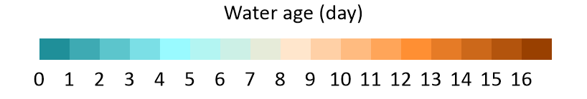
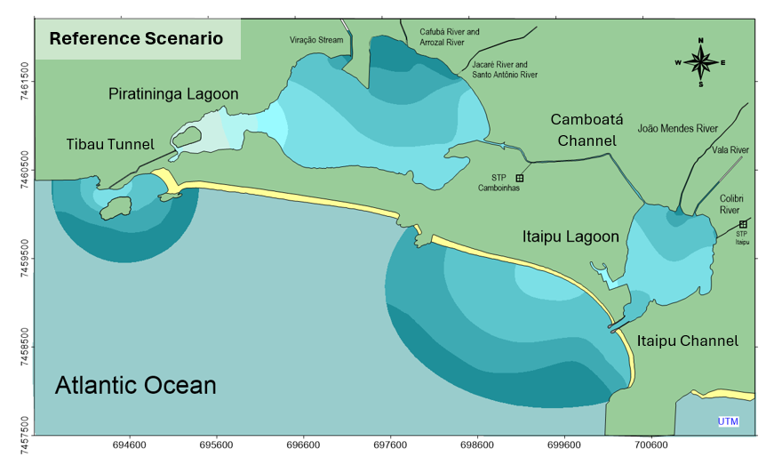
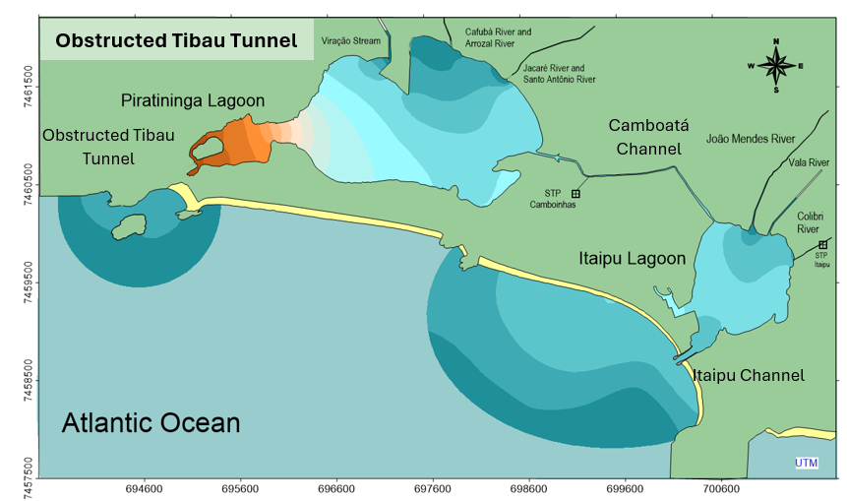
Figure 15 - Water age after 70 days of simulation for the Reference Scenario, above, and for the Obstructed Tibau Channel, below.

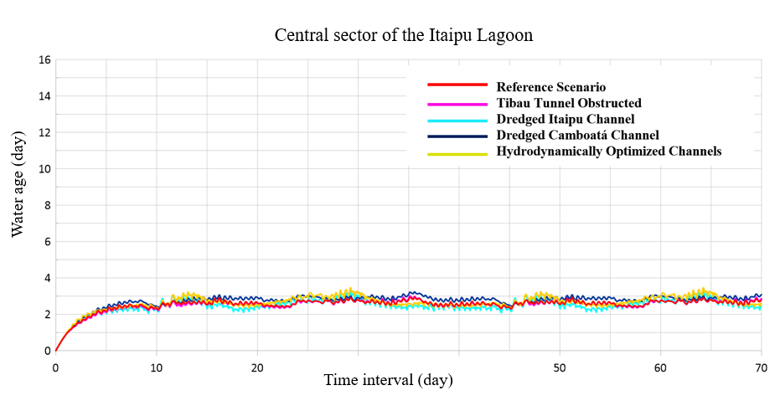
Figure 16 – Comparative water age time series among the simulations analyzed for the central sector of Itaipu Lagoon.
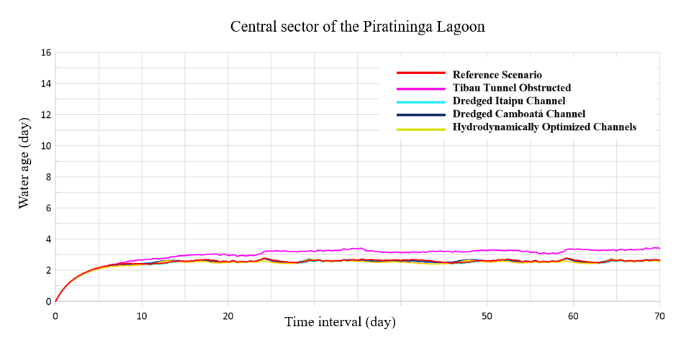
Figure 17 - Comparative water age time series among the simulations analyzed for the central sector of Piratininga Lagoon.

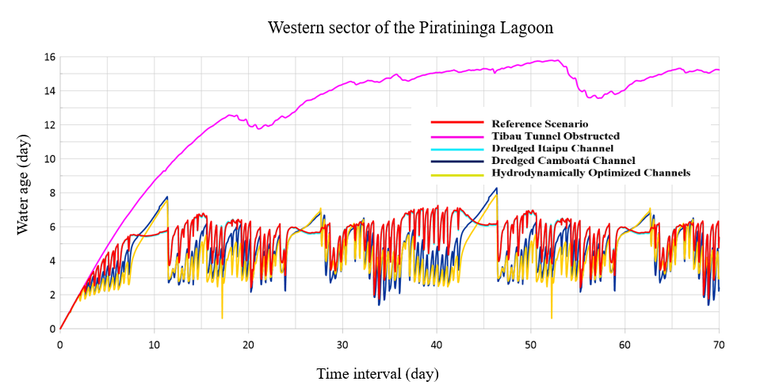
Figure 18 – Comparative water age time series among the simulations analyzed for the western sector of Piratininga Lagoon.

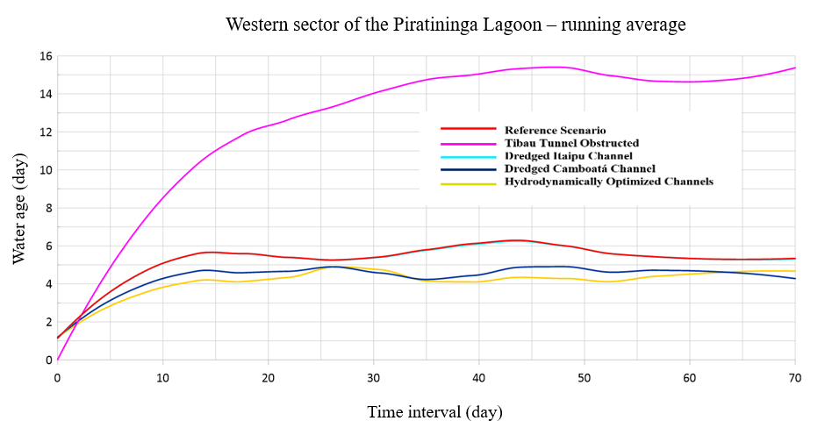
Figure 19 – Running average of water age time series for all the simulated scenarios the Western Sector of Piratininga Lagoon.

Figure 8 showed that the water level in the Piratininga Lagoon is most of the time higher than the water level in Itaipu Lagoon and in the ocean. Thus, in HOC scenario, the new water from the ocean enters the Piratininga Lagoon through the Tibau Tunnel, crosses the Lagoon and mixes with the new water discharged by the rivers. These waters tend to drain easier through the Camboatá Channel and, after that, through the Itaipu Channel, creating a residual flow, or a water drift, which significantly reduces the water age, as Figure 20 depicts.
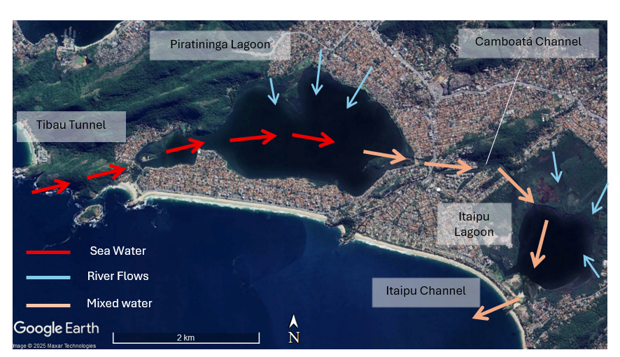
Figure 20 – When the Camboatá Channel is dredged, a residual flow, of circulation cell is created. The sea water (red arrows) drifts from the Tibau Tunnel towards east and mixes with the water from the rivers (light blue arrows. This mixed water (pink arrows) drains through the Tibau Tunnel, passes through the Itaipu Lagoon and leaves the Lagoon System through the Itaipu Channel.

- Conclusions
This article assessed hydrodynamical behavior, as well as water renewal and water age patterns in the Piratininga-Itaipu Lagoon System, a coastal body of water located in a densely populated urban area, which is increasingly facing vulnerability issues. Through numerical modeling, several interventions were analysed, to increase the resilience of this environment.
The performed simulations revealed that water renewal and water age patterns in the Piratininga-Itaipu Lagoon System are strongly influenced by the structural and operational integrity of its tidal inlets and of the Camboatá Channel, which connects both Lagoons. In virtue of its limited connection to sea, the Piratininga Lagoon is the most fragile compartment of the lagoon system.
As the main findings of this research, the modeling results demonstrated that:
- River discharges are the main source of water renewal in the central sector of the Piratininga Lagoon. This conclusion reinforces the importance of sewage collection and treatment in the region, to improve water quality of the rivers flowing into the Piratininga Lagoon.
- The western portion of the Piratininga Lagoon shows a clear tendency of water stagnation. The Tibau Tunnel plays a critical role in mitigating this behavior, as it provides new marine water to that region.
- Dredging and clearance of the Camboatá Channel creates a circulation cell, or a water drift from west to east, or from the Tibau Tunnel to the Camboatá Channel, which significantly improves water renewal and water age in the western region of the Piratininga Lagoon.
- The water column in the Piratininga Lagoon reduced 0.1 to 0.2 m in the scenarios in which the Camboatá Channel was dredged. This fact suggests that attention should be given to this intervention, since it can lead to bottom exposure and release of bad odors from mud banks. As an alternative, an additional sill may be implemented at the mouth of the Camboatá Channel, for water level control. Different dredging scenarios may also be studied, so the hydrodynamic benefits can be achieved without exposing the bottom excessively.
- Dredging of the Itaipu Channel provides important benefits for the Itaipu Lagoon but presented no significant influence on the dynamics of the Piratininga Lagoon as an isolated measure. However, in association with other interventions, it is an important measure for the whole Lagoon System. Furthermore, the long-term cross-sectional stability of this channel – its capacity of remaining unobstructed - would depend on the implementation of adequate jetties, which would have to extend further into higher depths.
This study emphasizes that the proposed interventions are crucial for enhancing the environmental quality of the Piratininga-Itaipu Lagoon System. Such measures have the potential not only to mitigate stagnation effects in critical areas, but also to ensure a more sustainable and resilient water dynamic, which is essential for the environmental preservation and balanced use of this important body of water.
It is worth noting that this study did not consider aspects related to water quality in terms of their physical-chemical and biological components. As already discussed, the models see river water as new water. In reality, this new water is not necessarily clean water. New water is clean only if pollution sources are absent.
Like several other coastal lagoons worldwide, in the next few decades the region around the Piratininga-Itaipu Lagoon System will possibly have to deal with issues regarding sea level rise, extreme rainfall events and extreme wave events. The development of studies and strategies for dealing with these issues is not only necessary, but urgent.

